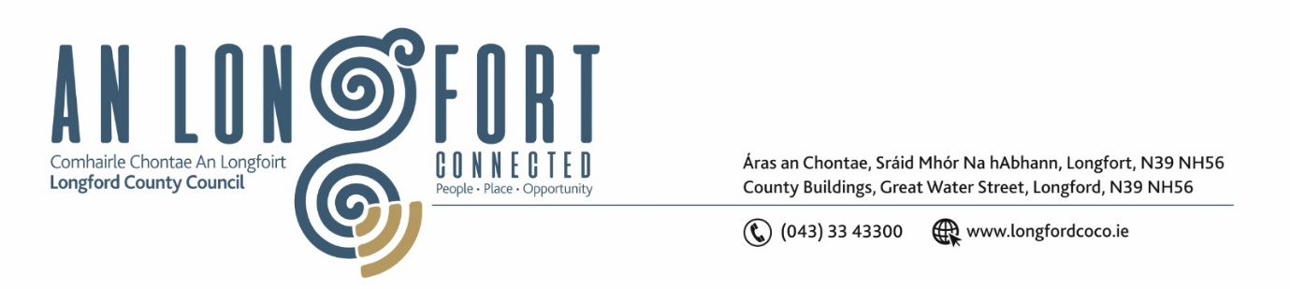

**LONGFORD MUNICIPAL DISTRICT**

***Please note meeting will be held in the Council Chamber, Aras an Chontae and via Microsoft Teams***

**14 February 2024**

**To: Each Member of Longford Municipal District.**

**Dear Member,**

You are requested to attend the Meeting of Longford Municipal District to be held in **the Council Chamber, Aras an Chontae** and **via Microsoft Teams** on **Wednesday 21 February 2024 at 4pm** to transact business, as set out on the agenda hereunder.

**Yours sincerely**,

_______________

**Claire McNabola**

**Meetings Administrator**

**AGENDA**

Prayer before meeting.

**1.** Confirmation of Minutes:

1. Longford Municipal District Meeting held on Wednesday 24 January 2024 – enclosed.
2. Longford Municipal District Committee Meeting held on Wednesday 24 January 2024 – enclosed.

**2.** Matters arising from Minutes.

**3.** Declaration of Interest by Members.

**4.** Management Report

**5.** Community Grant Support Scheme 2024

**6**. Consideration and adoption of Draft Municipal District Report for inclusion in

Longford County Council 2023 Annual Report – to follow

**7.** Town Twinning Report – enclosed

**8.** Notices of Motions, submitted by Councillors, as listed hereunder:

**Councillor Uruemu Adejinmi**

1. I call on Longford County Council to implement a Low Cost Safety Scheme to facilitate safe crossing of pedestrians in front of the Cinema and the apartment buildings across the road.